**San Francisco Bay University**

**MATH201 - Calculus-I**

**Homework Assignment #4**

**Due day: 8/6/2023**

**Instruction:**

1. **Push the answer sheet to GitHub in word file**
2. **Overdue homework submission could not be accepted.**
3. **Takes academic honesty and integrity seriously (Zero Tolerance of Cheating & Plagiarism)**
4. (a) Graph in Excel the function $f\left(x\right)=\sin\left(x\right)-\frac{1}{1000}sin⁡(1000x)$ in the viewing rectangle [-2π, 2π] by [-4, 4]. What slope does the graph appear to have at the origin?

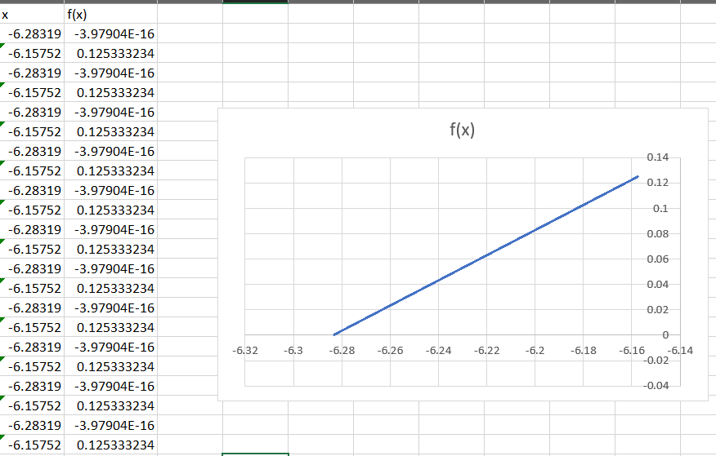

The graph appears to have a slope of 0 at the origin.

(b) Zoom in to the viewing window [-0.4, 0.4] by [-0.25, 0.25] in Excel and estimate the value of $f'(0)$. Does this agree with your answer from part (a)?

Yes, the answer agrees from part (a)

(c) Now zoom in to the viewing window [-0.008, 0.008] by [-0.005, 0.005] in Excel. Do you wish to revise your estimate for $f'(0)$?

No. It remains unchanged

1. Graph in Excel the function $f\left(x\right)=x+\sqrt{|x|}$. Zoom in repeatedly, first toward the point (-1, 0) and then toward the origin. What is different about the behavior of *f* in the vicinity of these two points? What do you conclude about the differentiability of *f* ?

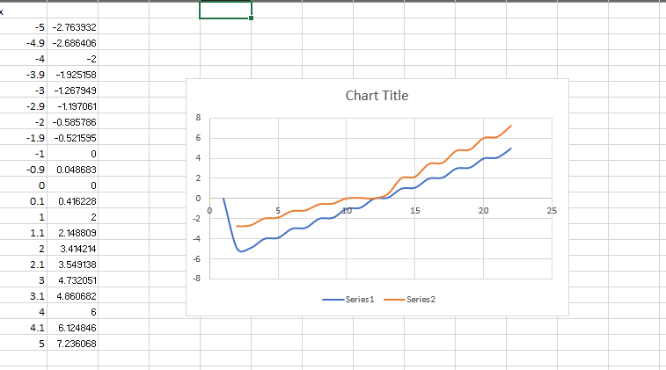

We can conclude that the function $f\left(x\right)=x+\sqrt{|x|}$.  is not differentiable at the origin.

1. The left-hand and right-hand derivatives of *f* at *a* are defined by

$${f^{'}}_{-}\left(a\right)=\lim_{h→0^{-}}{\frac{f\left(a+h\right)-f(a)}{h}}$$

and $${f^{'}}_{+}\left(a\right)=\lim_{h→0^{+}}{\frac{f\left(a+h\right)-f(a)}{h}}$$

if these limits exist. Then $f'(a)$ exists if and only if these one-sided derivatives exist and are equal.

1. Find ${f'}_{-}(4)$ and ${f'}_{+}(4)$ for the function

$$f\left(x\right)=\left\{\begin{matrix}\begin{matrix}0 & if x≤0\end{matrix} \\ \begin{matrix}5-x & if 0<x<4\end{matrix} \\ \begin{matrix}\frac{1}{5-x} & if x≥4\end{matrix}\end{matrix}\right.$$

Ans:

f^'_- (4)=lim┬(h→0^- )〖(f(4+h)-f(4))/h〗

f^'_- (4)=lim┬(h→0^- )〖(f(4+h)-1)/h〗

f(4 + h) = 5 - (4 + h) = 1 - h

f^'_- (4)=lim┬(h→0^- )〖((1-h)-1)/h〗 = lim┬(h→0^- )〖(-h)/h〗 = -1

f^'_+ (4)=lim┬(h→0^+ )〖(f(4+h)-f(4))/h〗

f^'_+ (4)=lim┬(h→0^+ )〖(f(4+h)-1)/h〗

f^'_+ (4)=lim┬(h→0^+ )((1-h-1)/(h*(1-h))) = lim┬(h→0^+ )(-1/(1-h)) = -∞

1. Sketch the graph of *f*.

(c) Where is *f* discontinuous?

The function f(x) is discontinuous at the point x = 4

(d) Where is *f* not differentiable?

The function f(x) is not differentiable at the point x = 4

1. If *f* is a differentiable function and $g\left(x\right)=xf(x)$, use the definition of a derivative to show that $g'(x)=xf^{'}\left(x\right)+f(x)$

Ans: $f^{'}(x)=\underset{h→0}{lim⁡}\frac{f(x+h)-f(x)}{h}$

$g^{'}(x)=\underset{h→0}{lim⁡}\frac{g(x+h)-g(x)}{h}$

$$=\underset{h→0}{lim⁡}\frac{(x+h)f(x+h)-xf(x)}{h}$$

$$=\underset{h→0}{lim⁡}\frac{(x+h)f(x+h)-xf(x)+hf(x)-hf(x)}{h}$$

$$=\underset{h→0}{\lim{}}\frac{\left(x+h\right)f\left(x+h\right)-xf\left(x\right)-hf\left(x\right)+hf\left(x\right)}{h}$$

$$=\underset{h→0}{lim⁡}\frac{(x+h)f(x+h)-xf(x)-hf(x)}{h}+\underset{h→0}{lim⁡}\frac{hf(x)}{h}$$

=h→0lim​(x+h)hf(x+h)−f(x)​−h→0lim​f(x)hh​+f(x)

=xf′(x)+f(x)

1. Boyle’s Law states that when a sample of gas is compressed at a constant temperature, the pressure *P* of the gas is inversely proportional to the volume *V* of the gas.
   1. Suppose that the pressure of a sample of air that occupies *0.106 $m^{3}$* at *25℃* is *50 kPa*. Write *V* as a function of *P*.

PV=k

50 kPa×0.106 m^3=k

k=5.3 kPa⋅m^3

PV=k V=P/k​

V = 5.3kPa . m^3 / P

V(P) = 5.3 kPa . m^3 / P

* 1. Calculate $\frac{dV}{dP}$ when *P = 50 kPa*. What is the meaning of the derivative? What are its units?

V(P) = 5.3kPa . m^3 / P

dV/dP = d/dP (5.3 kPa . m3 / P)

= - 5.3 kPa . m^3 / p^2

dV/dP | p = 50 Kpa = - 5.3 kPa . m^3 / (50 kPa) ^2

= - 5.3m^3/2500 kPa

= - 0.00212m^3/ kPa

1. Car tires need to be inflated properly because overinflation or underinflation can cause premature tread wear. The data in the table show tire life *L* (in thousands of miles) for a certain type of tire at various pressures *P* (in $lb/{in}^{2}$).

|  |  |  |  |  |  |  |  |
| --- | --- | --- | --- | --- | --- | --- | --- |
| *P* | *26* | *28* | *31* | *35* | *38* | *42* | *45* |
| *L* | *50* | *66* | *78* | *81* | *74* | *70* | *59* |

* 1. Use a calculator to model tire life with a quadratic function of the pressure.
 $$L=-0.054P^{2}+4.18P-48.7$$

 2. Use the model to estimate $\frac{dL}{dP}$ when *P = 30* and when *p = 40*. What is the meaning of the derivative? What are the units? What is the significance of the signs of the derivatives?

$$L=-0.054P^{2}+4.18P-48.7$$

dL/dP = d/dP (- 0.054p^2 + 4.18P – 48.7)

= - 0.108P + 4.18

dL/dP | p = 30 = -0.108(30) + 4.18

= 0.54

dL/dP |p=40 = -0.108(40) + 4.18

= -0.14

The derivative dL/dP shows how tire life L changes with pressure P. When P = 30, the derivative is positive, meaning increasing pressure will increase tire life. When P = 40, the derivative is negative, meaning increasing pressure will decrease tire life according to the model

The derivative’s units are thousands of miles/lb/in^2, representing the change in tire life per unit change in pressure

The sign of the derivative shows if tire life increases or decreases with pressure according to the model. A positive derivative means increasing pressure increases tire life, while a negative derivative means it decreases tire life